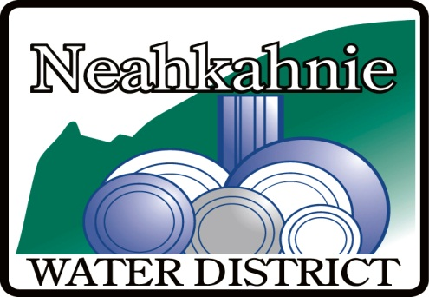

NEAH KAH NIE WATER DISTRICT

ADVISORY COMMITTEE MEETING

FRIDAY, AUGUST 22, 2025

2:30 PM VIA VIDEO CONFERENCE & IN PERSON AT THE OFFICE
(Ph: 503-368-7309 for instructions)
9155 NEHALEM ROAD in NEAH KAH NIE BEACH

AGENDA

- CALL TO ORDER – Date, start time, and who is in attendance.

- PUBLIC MEETING under ORS 192.630

The Committee is composed of Neahkanie community members that will advise the Board on matters related to water storage infrastructure. Members are: Craig Nern, David Boone, Pam Greene, Mike Woodin, Andrew Beyer, Stuart Jones, John Bloom, and Marc Johnson.
- Scope of Committee activity

- Discussion of current infrastructure

- Outline of possible strategies related to growth and firefighting reserves

- Discussion of tank locations, materials and costs
.

- PUBLIC COMMENT

- ADJOURNMENT

